**Moraga School District**

**Cultural Proficiency Committee (CPC) Agenda**

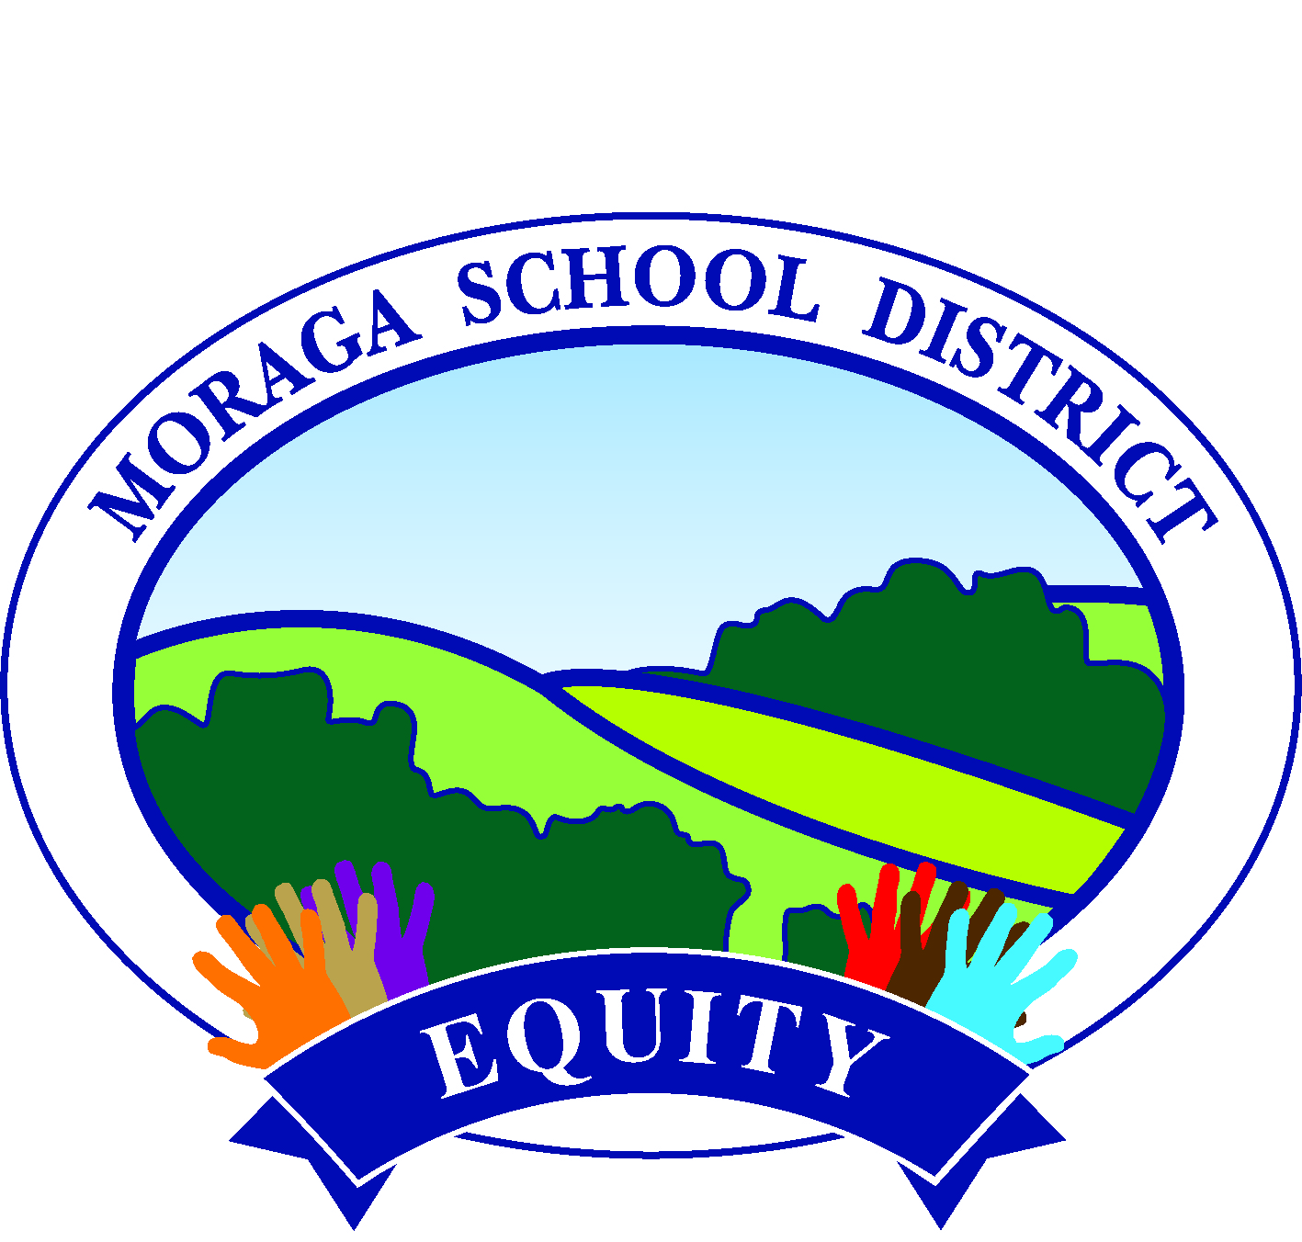

**10.18.21**

**6:30 - 8:00 PM**

<https://zoom.us/j/97568371749>

|  |  |  |
| --- | --- | --- |
| **Norms**  Stay Engaged, Actively Engage  Speak Your Truth and Share the Space  Experience Discomfort  Accept/Expect Nonclosure  Truly and Deeply Listen, Allow Time to Process before Responding  Commit to Action  **Processing Norms**  No recording  Review commitments at the end of the meeting. | | |
| **Topic** | **Notes** | **Outcomes** |
| Welcome and Introductions *(Believing)*   * Meet a Friend |  |  |
| The Compass and Norms   * Norms Review |  |  |
| Goal Setting and Updates *(Thinking)*   * Updates on Goals * Equity Plan Process Updates |  |  |
| School Break-Out Work *(Acting)*   * Further develop potential action steps * Reflect on site work and plan for the future * Share out |  |  |
| Closure *(Feeling)*   * Expressing Gratitude |  |  |